YEAR 9 SCIENCE
PHYSICAL SCIENCES
LENSES

• Do the following activity.
• Record your results on a sheet of paper in your group.
• Take a photo and add it below this page.
• Answer the questions.

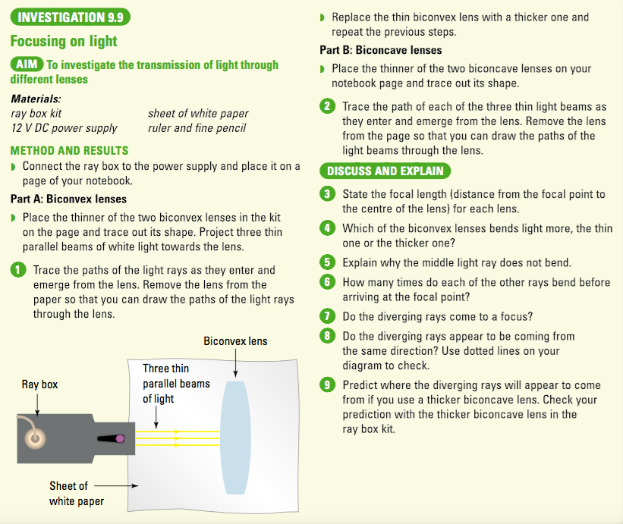

Observations

• Place your photo of the results here.

Discuss and Explain

• Answer the questions here.

